Website Planning Document

# The Mountain Spoke Site

Author: Chandler Noble Hatch

# Site Purpose

To showcase different trails and bikes for the montana area

# Target Audience

Outdoor enthusiasts, tourists and mountain biking enthusiasts.

# Site Map

# Color Scheme

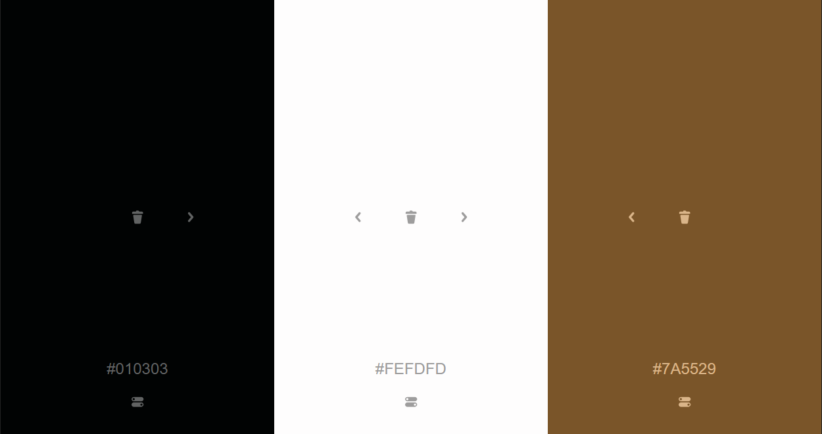

# Typography

Title

font-family: 'Lobster', cursive;

Body

font-family: 'Alegreya', serif;

# Wireframe Sketches

